CS 161
Assignment #8
Caesar Cipher

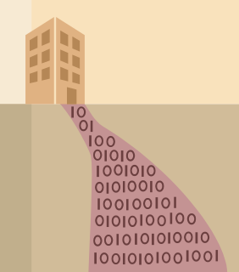

Background:

One of the simplest examples of an encryption technology is the Caesar cipher, which is said to have been used by Julius Caesar to communicate with his army. Caesar is considered to be one of the first persons to have ever employed encryption for the sake of securing messages. Caesar decided that shifting each letter in the message would be his standard algorithm, and so he informed all of his generals of his decision, and was then able to send them secured messages. Using the Caesar Shift (3 to the right), the message,
"Return to Rome" would be encrypted as, "Uhwxuq wr Urph".

Note that only letters are encoded. Punctuation, spaces, newlines, and so forth are not encoded. Lower case letters are encoded into lower case letters, and upper case letters are encoded into upper case letters. Also, note that the encoding system “wraps around” at z and Z. So the letter ‘y’ is encoded as ‘b’ using a Caesar Shift (3 to the right).

A good reference to learn more about the Caesar Cipher is Wikipedia.

Your assignment is to write a C++ program which will automatically decrypt virtually any Caesar coded message. It should rely on the fact that the letter ‘e’ is the most frequently appearing letter in the English language. So if you can determine which letter appears most frequently in the encrypted message, you can determine which letter is the encoded equivalent of ‘e’. This, in turn, lets you calculate the amount of the Caesar “shift”. If you unshift the encoded message by the same amount, you should be able to produce the original “clear text” message.

I have uploaded an encrypted message using a Caesar Cipher for you to decrypt. Have fun!

Deliverables:

Please upload your program source code (.cpp file) as usual.

Notes:

Please try to design your solution to use as many aspects of this class as possible. For example, try to modularize your solution using C++ functions wherever you can. Also, I think you will need to use an array to determine which letter appears most frequently in the encoded message. Your program should prompt the user to enter the file name of the input (encrypted) file and print to the screen, and should provide appropriate error handling as necessary.

